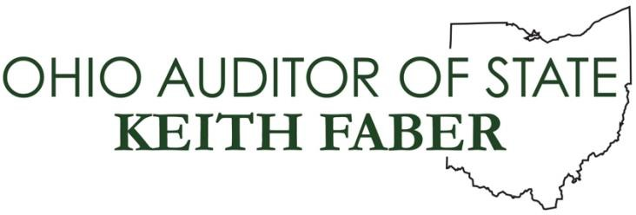
Public Affairs Contact: Marc Kovac press@ohioauditor.gov

For Immediate Release:
April 2022

Sunshine Week: Auditor Faber Releases Second Year StaRS Report
Columbus – In conjunction with Sunshine Week, Auditor of State Keith Faber announced over 3,500 reviews of Sunshine Law compliance are available on the Auditor’s STaRS website.
Auditor Faber launched the StaRS program in 2019 in an effort to promote government
“The goal of the StaRS program is to encourage public agencies to strive for greater transparency, and two years into the program, we are seeing those improvements,” Auditor Faber said. “Through this program, we have been able to recognize the entities excelling in open records and identify the areas where we can help our local partners get better so Ohioans have the access they deserve to public information.”
All StaRS results are available online.
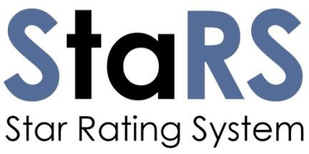

StaRS launched
In March 2019, Ohio Auditor of State Keith Faber announced his plan to create a program that would encourage public entities to be more open and transparent. Previously, while serving as Ohio Senate President, Auditor Faber worked with the Court of Claims to establish an independent and affordable process for citizens to have their public-records complaints heard and determined.
To build upon the success achieved with the public-records mediation program and further promote more open and transparent government operations, the “StaRS” public records system was launched in November 2019. The stars ratings were created to acknowledge the accomplishments of those that were meeting Ohio’s public-records and open-meetings laws, and also to recognize those public bodies that
were exceeding those legal standards by implementing a number of identified best practices.
While the State Auditor has always audited public-records compliance, this additional acknowledgement of the efforts being made to serve the public and provides incentive to do more, when possible, in making records more accessible.
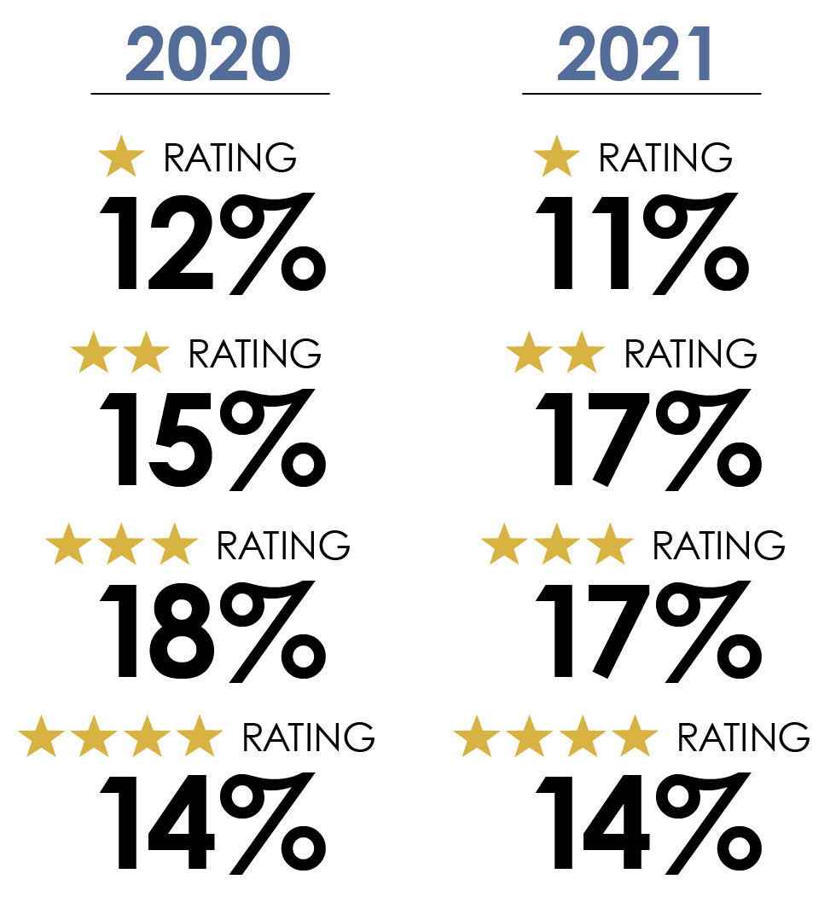
Making the Grade
A single star is awarded to a public body that meets the necessary public records demands of Ohio’s Sunshine Laws. These entities are considered to be conducting public business in an open and transparent manner. Additional stars are awarded for the implementation of best practices that help ensure that records are more easily accessible to the public, with a four-star rating indicating a public body has implemented a number of additional efforts and policies.
It’s important to note that receiving even a single star is an accomplishment in maintaining public records in a standard that meets Ohio law. Ratings of two, three, or four stars are given when an entity exceeds those standards by implementing best practices suggested by the State Auditor’s Office. Many smaller entities may not have the staff or technological capabilities to introduce these best practices, but that should not diminish their efforts in serving their citizens in an open and transparent manner.
Compliance and Achievement
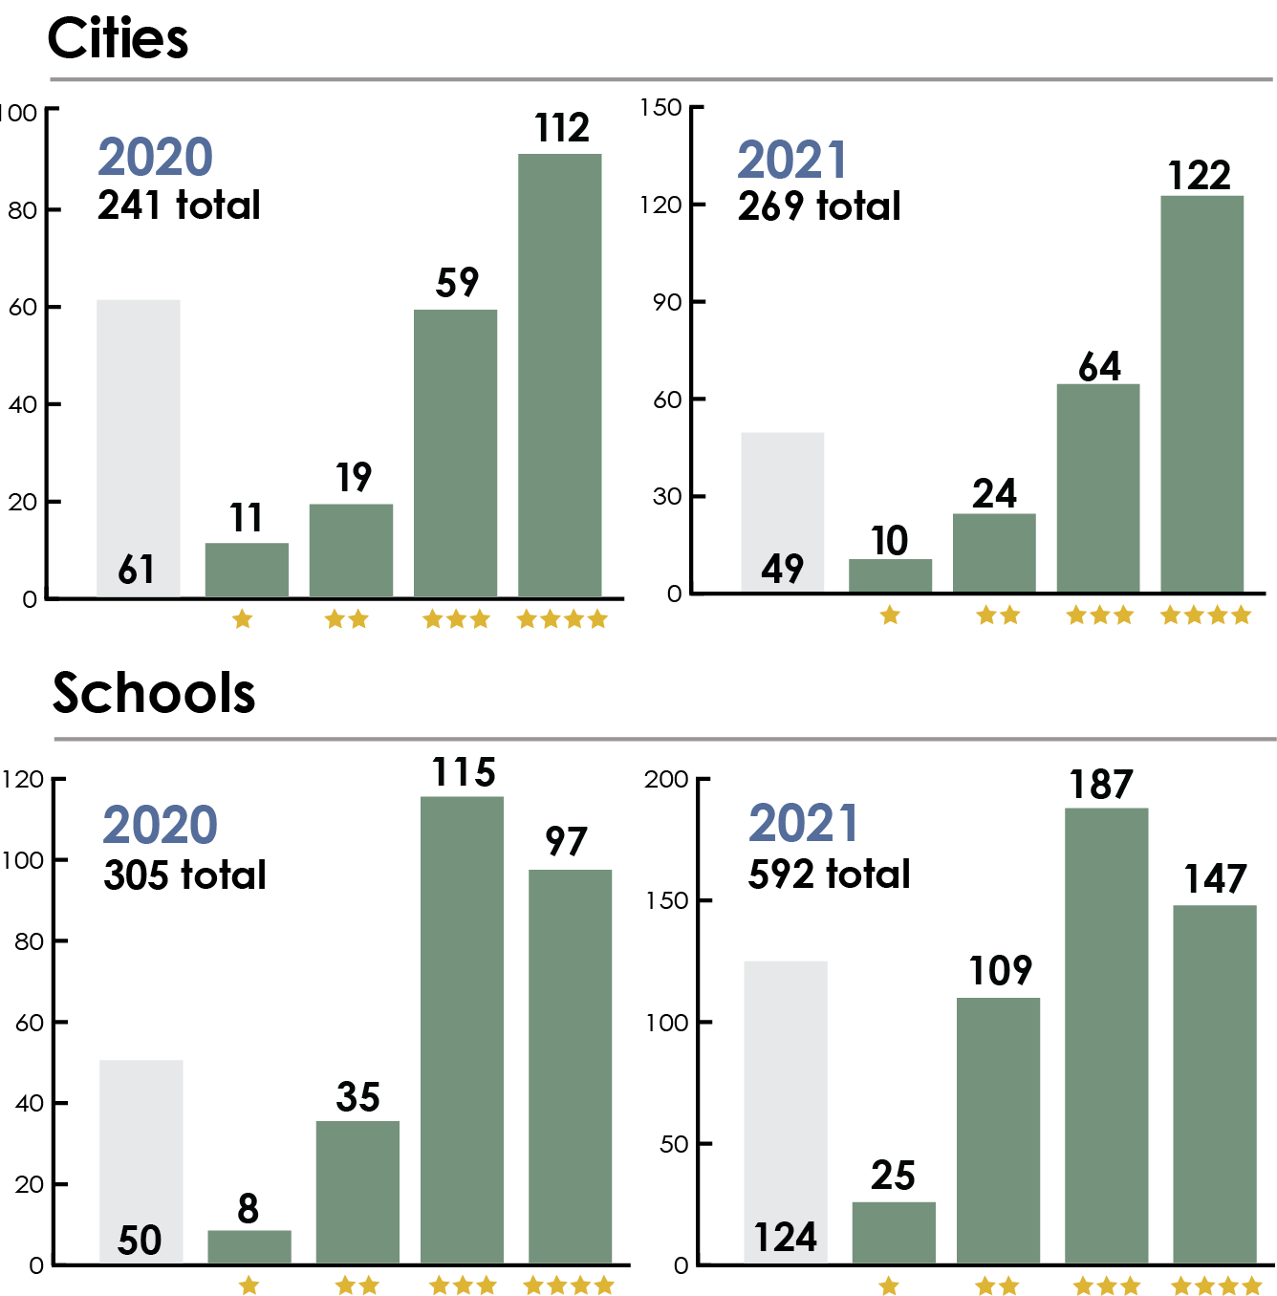
Since the StaRS rating system began, 3,573 entities have been audited for public records compliance. More meeting Ohio’s public record laws. This includes 508 local governments, schools, first-responder agencies, and other public bodies that have achieved a four-star rating – the highest honor. Entities should continue to work toward implementing best practices whenever possible and these numbers will most certainly grow as our partners grow to be familiar with this new program.
A couple notable achievements were identified in the ability of Ohio’s cities and schools to implement best practices. Of the 269 cities AOS provided ratings for, 210 received ratings of two stars or more. Additionally, Ohio’s public schools had 443 ratings of two stars or better of the 592 audits completed. These two entity types seem to excel, for the most part, at meeting both the legal demands of public record law while providing additional services for the public in their efforts to obtain public records.

Room to Improve
As for the 41% audited but found to be noncompliant, the Auditor of State’s Office is committed to working with our partners to help them achieve compliance and receive their star rating. What we typically found in this area was that public bodies that included a number of different offices under a single umbrella such as counties, townships, and villages experienced some struggles achieving compliance. Part of this challenge stems from the makeup of these entities, as a number of offices are often housed under a single heading. For example, if one office or office holder in a county is found not to be in compliance, the entire body is found to be noncompliant. Additionally, smaller units of government do, at times, experience staffing and technology challenges. Understanding these reasons for noncompliance does not excuse failure to comply with the law, but it does provide some context as these entities move toward compliance.
Digging Deeper
While the occurrences of noncompliant entities are concerning, positive notes exist beneath the surface of these figures. Many of the noncompliant entities have very simple fixes, like implementing a record retention schedule, posting their policy in public view or appointing a public records custodian. While these are required steps in achieving compliance, they can be easily addressed. While some entities certainly deserve a closer look for not properly maintaining public records, many of our public officials simply need to be made aware of these issues so they can seek remedy.
Encouraging Achievement
The StaRS program was implemented to track compliance among public entities, help the public hold government accountable, and provide our public officials a standard and incentive in their efforts to operate in an open and transparent manner. The first year of the program has identified both successes and failures within our public-records compliance system while also illuminating opportunities for public agencies to improve their efforts in serving the public. This program should lead to a greater movement toward government transparency.
Ohio’s Sunshine Laws are available on the Auditor of State website and are distributed to local governments by the office. More information about the StaRS program and local government ratings can be found in the Open Government section.
Now more than ever, government transparency is essential. State and Local governments must work together to ensure the public has the access it deserves.

